* The most important thing of the electrical measurements of the AFM including the conductive AFM and surface potential measurement is checking the manual of the AFM. The manual is available in the program of Brucker AFM (press F1). So, before start the experiment, please peruse the manual carefully.

Conductive AFM

1. Prepare the conductive tip (SCM-PIT-V2 tip).
2. Load the tip on the conductive module
3. 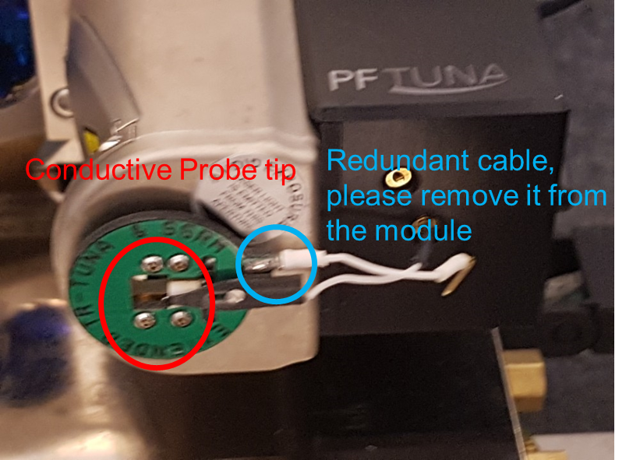
4. Start the AFM program.
5. Select the electrical measurement and the conductive AFM measurement.
6. Ground the sample with the machine. Please use the port # 13 or 14.

KPFM

1. Prepare the conductive tip (SCM-PIT-V2 tip).
2. Load the conductive tip on the normal module (Do not use the conductive module)
3. Start the AFM program.
4. Select the electrical measurement and the conductive AFM measurement.
5. Ground the sample with the machine. Please use the port # 13 or 14.

* Some of the substrates may absorb the moisture and foreign particles on the substrate. If so, the surface potential may be far off from the desired value. Thus, before the measurement, find the reference potential level of the substrate by pre-baking substrate.